**Centennial College**

**Comp 301: UNIX/LINUX Operating Systems**

**Assignment 02**

**Mudrak Patel ; 300878960**

1. Create a file called “Student_info” using the vi/emacs editor with the following information:

John:60:80:90

Jane:40:50:60

Mark:30:45:55

Beth:70:75:80

Luke:85:80:95

Smith:60:55:70

Rachel:60:70:55

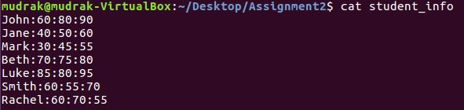

Write a shell script that does the following: (Use *awk* command for this task)

a) Takes this file as input and reformats it such that the data has a field heading and the fields are separated by tabs as displayed below:

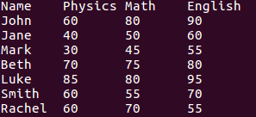

b) Stores this output in a new file called Student_All_Marks

c) Stores the output in the same format (that is had a header and the fields are separated by tabs) but containing only the Name and Physics marks in a file name “Student_Physics”. Repeat the same with English and Math marks.

d) Stores the name of the students who have marks >60 in Physics and >60 marks in Math in a separate file called Students_Top_Scorers

**(4 marks)**

1. Write a shell script to find all the files containing the word “Jane” (or jane. It should be case insensitive) on your desktop (Use the *grep* command). Write the shell script such that it reads the word to be located (Jane) and the path to search (your Desktop) from the command line. **(2 marks)**
2. Write a shell script to list all the files present on your Desktop that were created in the month of June. Display the latest files created first. (Hint: Use *ls* , *grep, sort* and pipe operator (|)) **(2 marks)**
3. Write a shell script to replace all uppercase letters to lowercase letters for an input file. (Use *tr* command)**(1 mark)**
4. Write a shell script to find the differences between the files ‘Student_All_Marks” and “Students_Top_Scorers”. **(1 mark)**